Font Explorer step by step Guide.

Tabs:

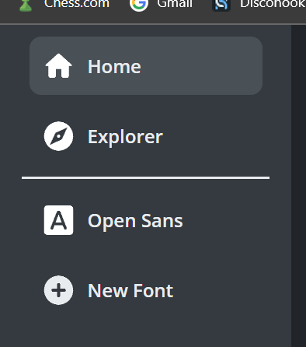the app contains three main tabs which each of them represents a different slide.

1. Home.

Contains the overview document and automatically focuses on application start-up.

1. Explorer.

Contains all the fonts provided by the app and doesn’t include any local fonts which you might have on your computer

1. Fonts Tab

you can add infinite font tabs as you like and each of them can represent a different font.

By default you have the Open Sans font tab, you can delete each font tab by hovering the mouse on the tab and pressing the remove icon.

Font Tabs

The Font Tab include a lot of sections and each of them has its own secrets which we explain each of them part by part

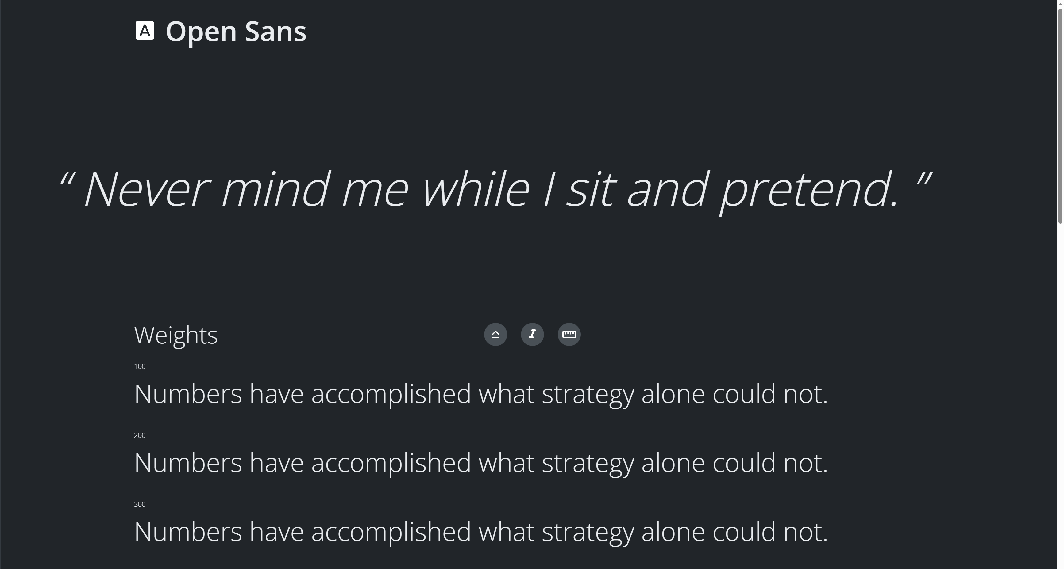

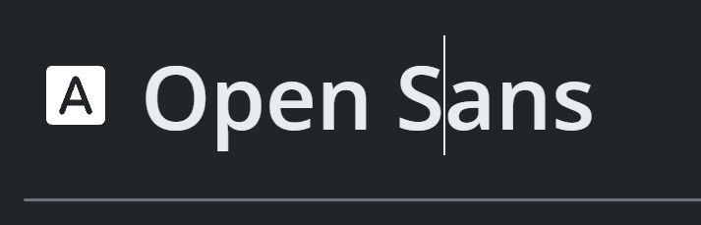The Title

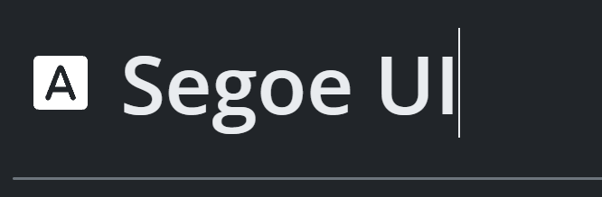It says what font you are currently viewing in the slide, as a feature you can rename it by just clicking it and set it to your favourite font (including your local fonts and the fonts that the app include)

The Quote

Just a small text to showcase your font on quotes

Weight Bars 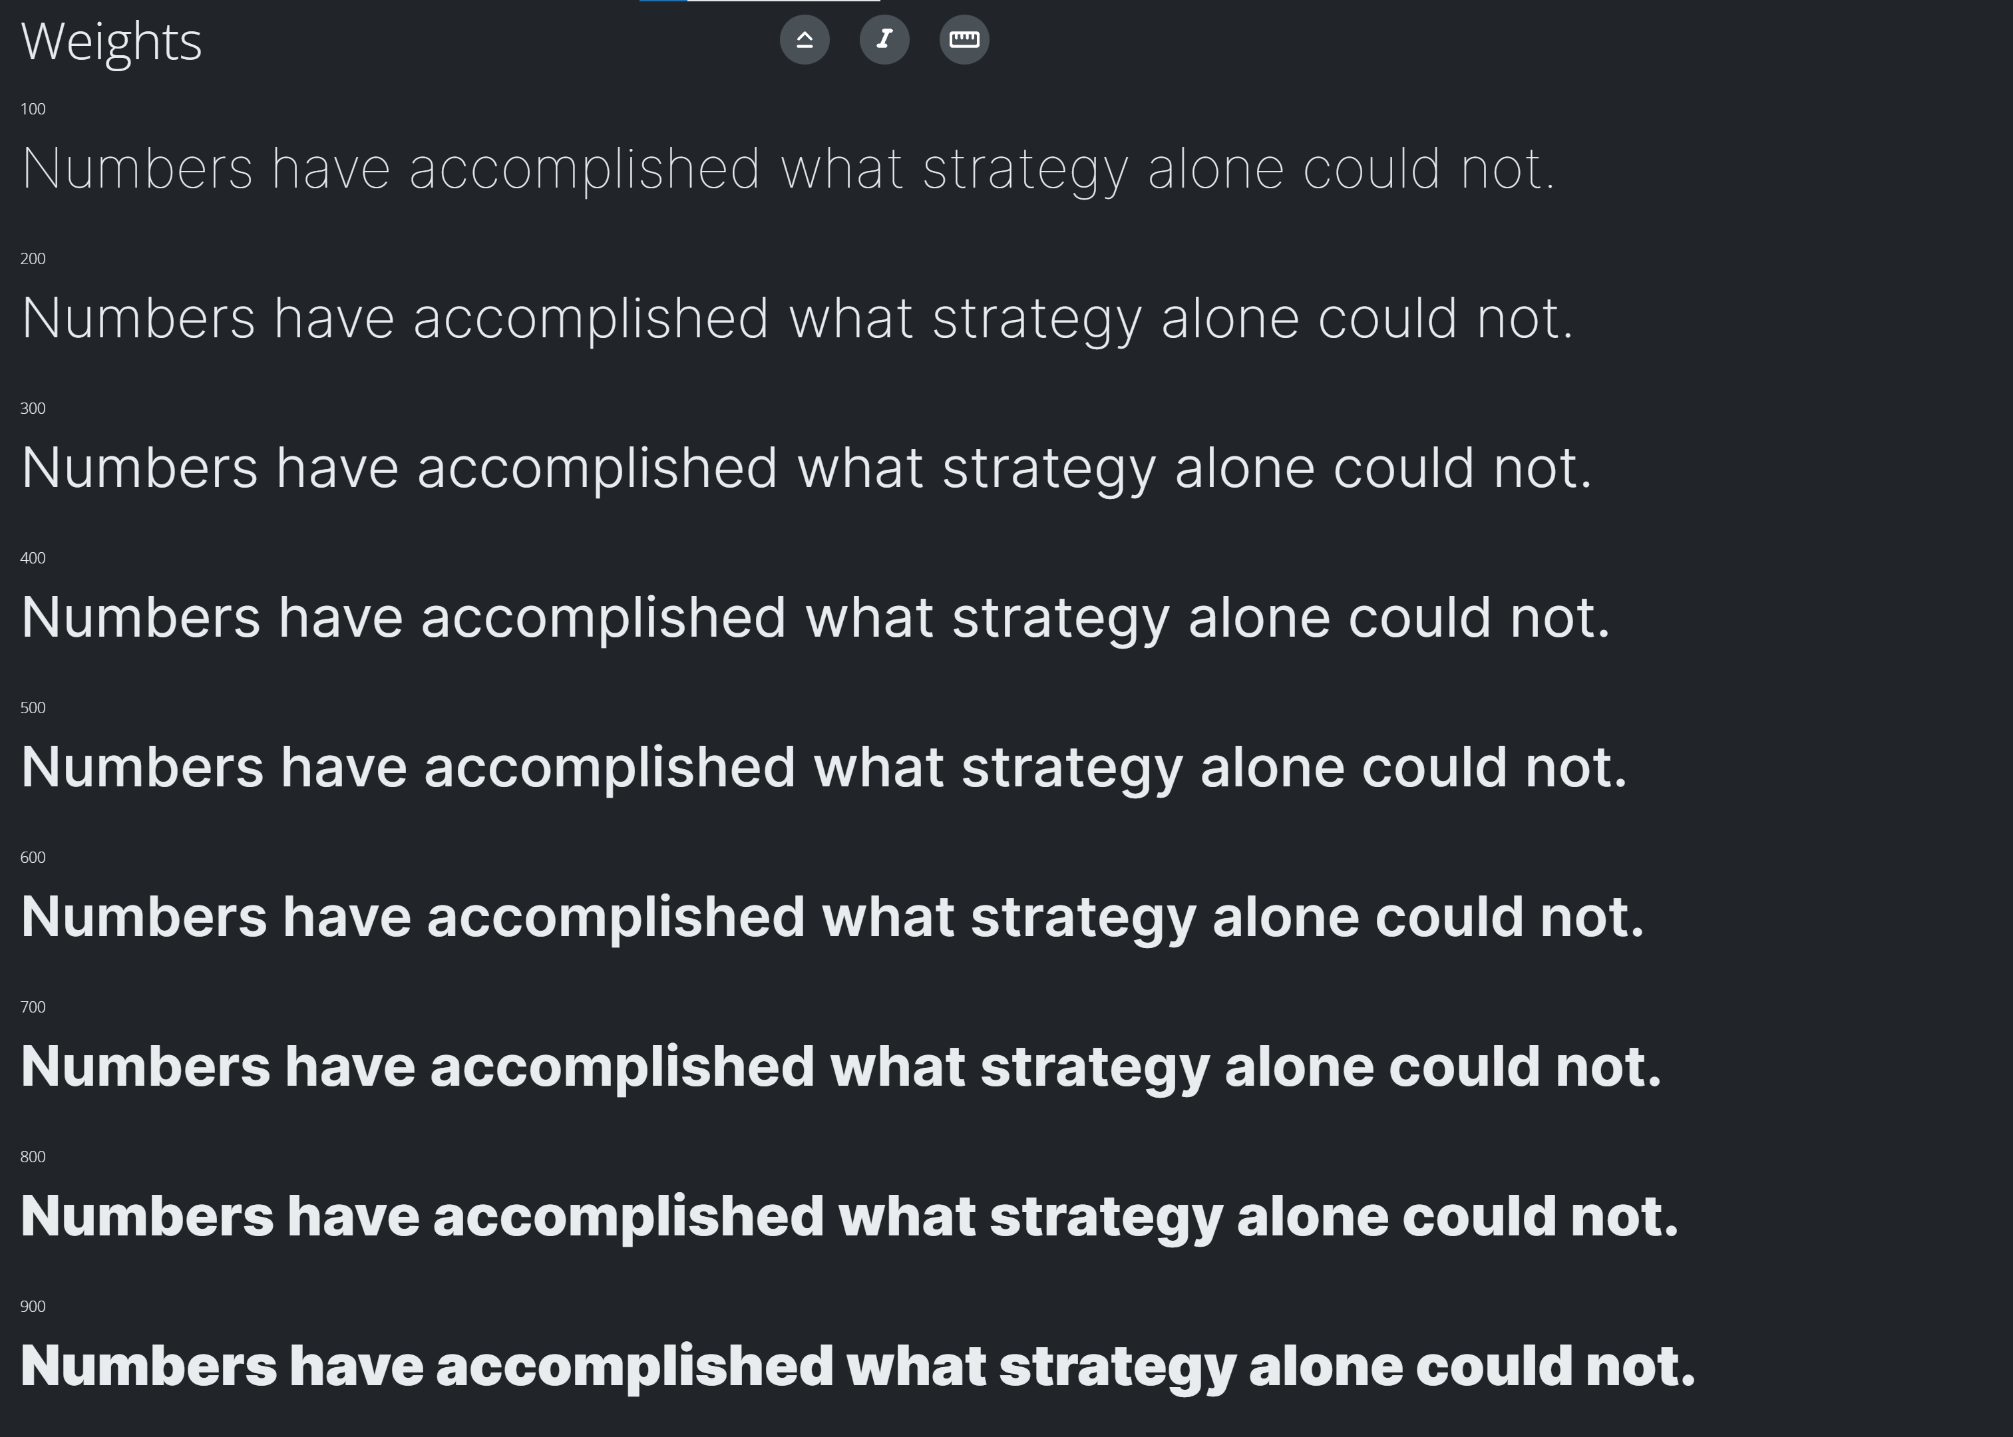

This section is made to compare different weights and how much **Bold** is each weight and which one suits your purpose.

There are 3 toggle buttons which they apply Italic, Condensed and Small Caps style to the texts in each weight bar

You can also change the text of it by clicking one of them and when you change one of them the others will change to.

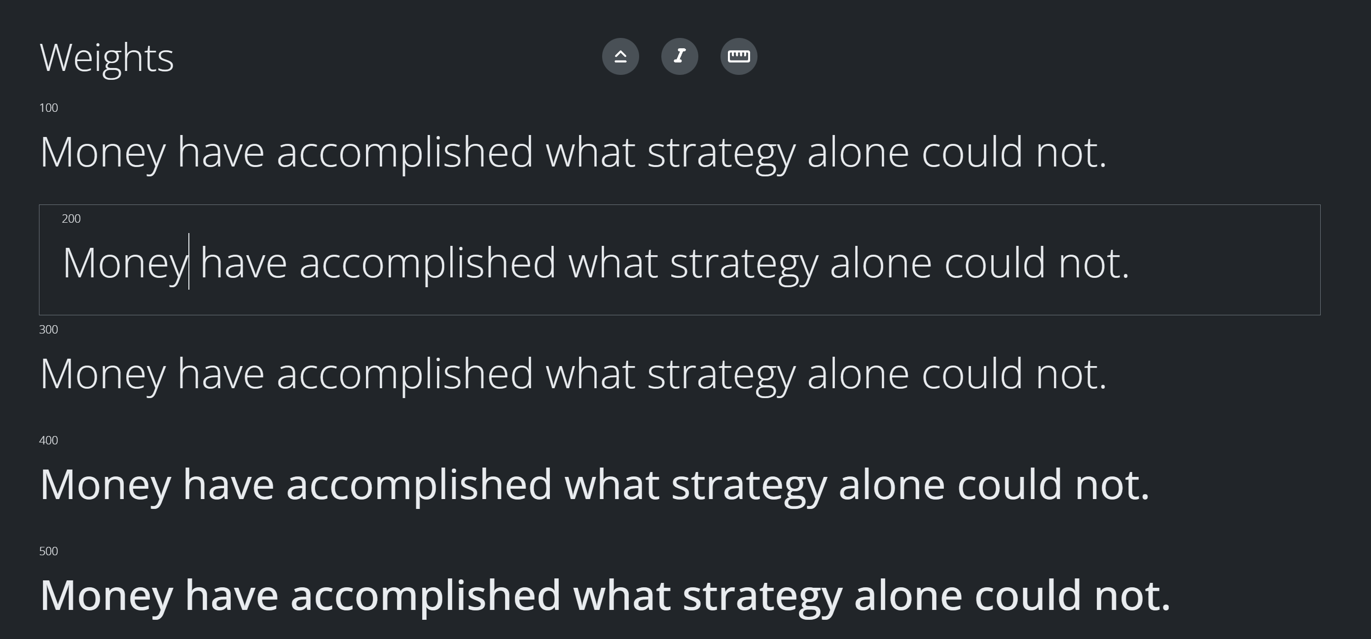

Glyphs

Glyphs section is made for peoples who want to check each letters and symbols of the Fonts.

by opening each accordion you can see a list of letters and symbols, by hovering over each of them you can see them with more details on the right column.

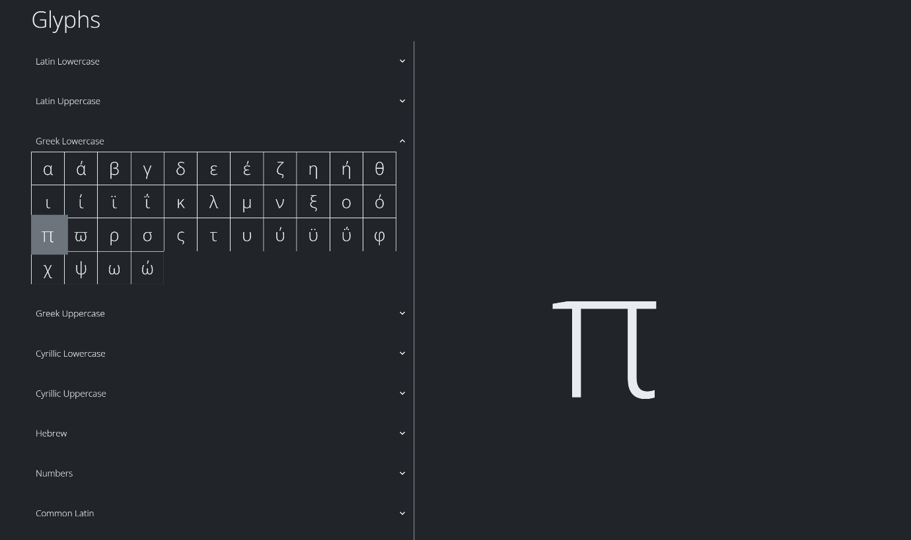As shown in below image, we preview the Greek Letter “π” which is commonly used in Mathematical and Scientific studies to calculate Circle area and border size.

Explorer Tab

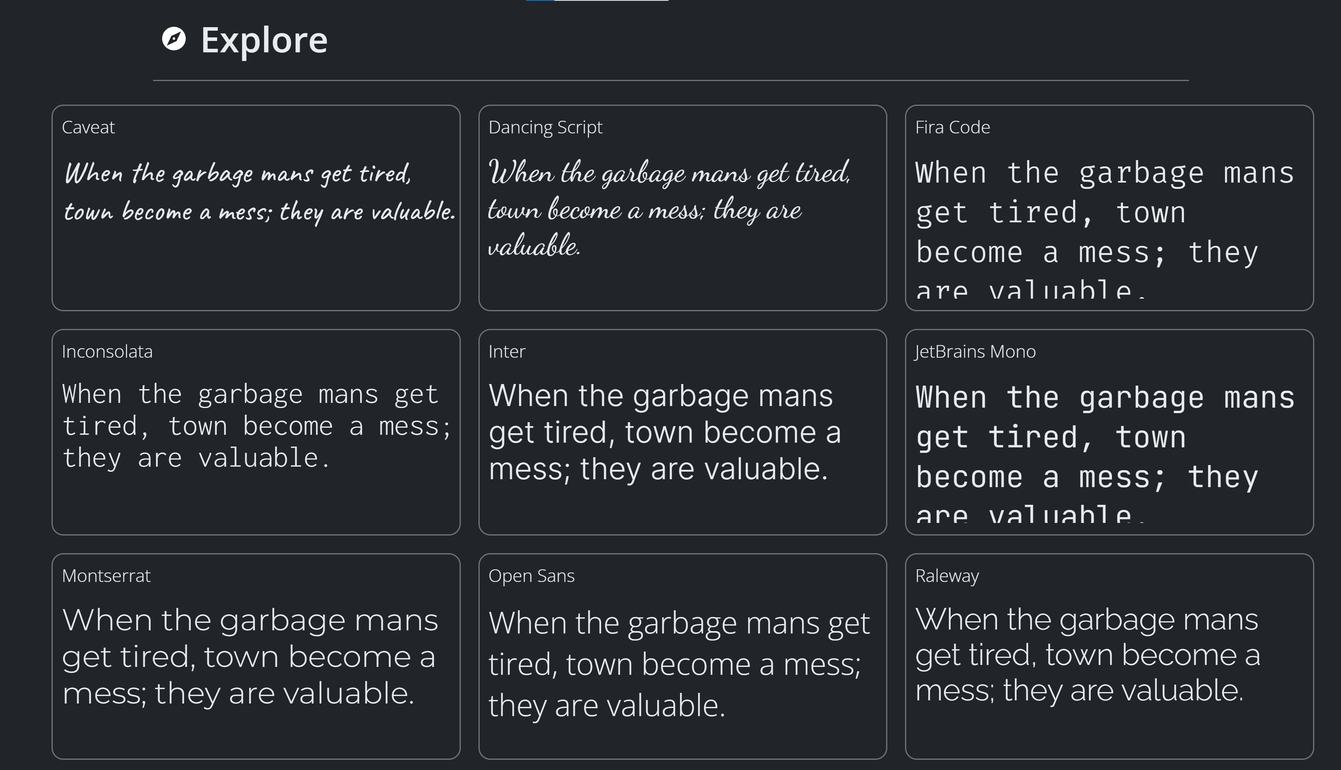It include all the fonts that Font Explorer has in it (not including your local fonts) and you can download and showcase each of them by hovering the mouse over them and either use the download button or add button to showcase it in a different Font Tab.

